Soccer Event Detection

**Introduction**

In recent years, there have been tremendous breakthroughs in the field of computer vision, which have enabled robots to perceive and interpret visual input with an extraordinary degree of precision. When it comes to the field of sports analytics, and more specifically soccer, the utilization of computer vision techniques has a tremendous amount of potential for the extraction of significant insights from live-action film and photographic data. The objective of this research is to construct a sophisticated model that is capable of identifying a variety of soccer-related events that are shown in photographs. This project digs into the domain of soccer incident detection.

Due to the fact that soccer is one of the games that is watched the most all over the world, it provides a wealth of visual data that is generated during matches. During the course of each match, a plethora of events take place, ranging from mundane plays such as corner kicks and tackles to crucial occasions such as penalties and substitutions. The technique of detecting and classifying these occurrences automatically from photographs not only simplifies the process of data analysis but also paves the way for creative applications in the fields of sports broadcasting, performance analysis, and referee aid systems.

This project's major purpose is to investigate whether or not it is possible to automate the process of detecting soccer events by using machine learning algorithms to picture data. The suggested model seeks to give significant insights into match dynamics, player performance, and strategic subtleties by precisely recognizing and categorizing occurrences. This will be accomplished when the model is implemented. Our presentation includes a full description of the methodology of the research, the results of the experiments, and some concluding observations. The purpose of this article is to shed light on the efficacy of our technique in solving the difficult issue of soccer event identification. This will be accomplished by illuminating the process of picture preprocessing, model training, and performance evaluation. In addition, we address potential options for future study and development in this rapidly developing topic, which lies at the crossroads of computer vision and sports analytics.

**Research Question and Methodology**

The central focus of this project revolves around addressing the following research question: Can machine learning techniques be effectively utilized to detect and classify soccer-related events depicted in images, and if so, what methodologies yield the most accurate results? To tackle this question, a systematic methodology is devised, encompassing several key steps aimed at preprocessing the image data, training multiple machine learning classifiers, and evaluating their performance. The methodology is designed to be comprehensive, covering various aspects ranging from data collection to model evaluation.

*Data Collection and Preprocessing*

The initial step involves gathering a comprehensive dataset of images captured from UEFA Champions League (UCL) and UEFA Europa League (EL) football matches. These images are manually annotated to label each image with the corresponding soccer event depicted. The dataset encompasses seven main events: corner kick, penalty, free kick, red card, yellow card, tackle, and substitution. Once the dataset is assembled, preprocessing techniques are applied to enhance the quality and relevance of the image data. This includes resizing images to a standard resolution, converting them to grayscale to simplify processing, and applying denoising algorithms to reduce background noise and enhance feature visibility. Additionally, techniques such as brightness and contrast adjustment may be employed to further optimize image quality and consistency.

*Feature Extraction and Model Training*

With the preprocessed image data in hand, the next step involves extracting relevant features from the images to facilitate event detection. This is accomplished using feature extraction algorithms tailored to capture distinctive characteristics of each soccer event. Common techniques include Histogram of Oriented Gradients (HOG), Local Binary Patterns (LBP), and Convolutional Neural Networks (CNNs) for deep feature learning.

*Model Evaluation and Performance Metrics*

The performance of each trained classifier is evaluated using a comprehensive set of performance metrics, including accuracy, precision, recall, and F1-score. These metrics provide quantitative insights into the classifier's ability to correctly classify images into their respective event categories. Additionally, confusion matrices are generated to visualize the distribution of predicted and actual event labels, enabling a deeper understanding of classification errors and misclassifications.

*Modeling*

we employ a diverse range of machine learning algorithms to tackle the task of soccer event detection in images. Each algorithm offers unique strengths and capabilities, contributing to the overall effectiveness and robustness of the event detection system. The following is an overview of the machine learning algorithms utilized in the project:

1. Logistic Regression

Logistic Regression is a linear classification algorithm commonly used for binary classification tasks. Despite its simplicity, logistic regression can effectively model the probability of a given input belonging to a particular class. In our context, logistic regression is applied to classify images into different soccer events based on extracted features. Despite its simplicity, logistic regression can be quite powerful when features are linearly separable or when the dataset is relatively small.

1. Support Vector Machines (SVM)

Support Vector Machines (SVM) are a versatile class of supervised learning algorithms capable of performing both linear and non-linear classification tasks. SVMs work by finding the hyperplane that best separates classes in feature space, maximizing the margin between different classes. SVMs are particularly well-suited for tasks with high-dimensional feature spaces, making them a valuable tool for image classification tasks like soccer event detection.

1. Decision Trees

Decision Trees are intuitive and interpretable machine learning models that recursively partition the feature space into regions based on feature values. Each node in the decision tree represents a decision based on a feature value, leading to the classification of instances into different classes. Decision Trees are robust to outliers and can handle non-linear relationships between features, making them suitable for complex classification tasks like event detection in soccer images.

4.Random Forests

Random Forests are an ensemble learning method that combines multiple decision trees to improve classification performance. By training a multitude of decision trees on random subsets of the dataset and aggregating their predictions, random forests can reduce overfitting and increase robustness. Random Forests are highly effective for tasks with high-dimensional feature spaces and complex decision boundaries, making them a popular choice for image classification tasks.

1. Ensemble Methods (Stacking and Bagging Classifiers)

Ensemble methods combine multiple base learners to produce a stronger predictive model. Stacking and bagging classifiers are two popular ensemble techniques used in this project. Stacking combines the predictions of multiple base classifiers using a meta-learner, while bagging (bootstrap aggregating) trains multiple instances of the same base classifier on different subsets of the training data. Both stacking and bagging classifiers leverage the diversity of base learners to improve overall classification performance and robustness.

*Cross-Validation and Hyperparameter Tuning*

To ensure the robustness and generalization capability of the trained models, cross-validation techniques such as k-fold cross-validation are employed. This involves partitioning the dataset into multiple subsets, training the model on a subset of the data, and evaluating its performance on the remaining subsets. By iteratively rotating the training and testing subsets, cross-validation provides a more reliable estimate of the model's performance on unseen data.

**Experimental Results**

*Dataset Overview*

The dataset utilized in this project consists of images captured from UEFA Champions League (UCL) and UEFA Europa League (EL) football matches, covering seven main events: corner kick, penalty, free kick, red card, yellow card, tackle, and substitution. The dataset is manually annotated to label each image with the corresponding soccer event depicted, providing ground truth labels for evaluation.

*Evaluation Metrics*

Performance evaluation is conducted using a comprehensive set of metrics to assess the effectiveness of the trained classifiers in accurately classifying soccer events in images. The key evaluation metrics include:

* Accuracy: The proportion of correctly classified images to the total number of images in the dataset, providing an overall measure of classifier performance.
* Precision: The ratio of true positive predictions to the total number of positive predictions, indicating the classifier's ability to avoid false positives.
* Recall: The ratio of true positive predictions to the total number of actual positive instances, reflecting the classifier's ability to capture all relevant instances of a class.
* F1 Score: The harmonic mean of precision and recall, providing a balanced measure of classifier performance that considers both false positives and false negatives.

*Results*

The experimental methodology involves partitioning the dataset into training and testing sets, preprocessing the image data, training multiple machine learning classifiers on the preprocessed data, and evaluating their performance using the aforementioned metrics. Multiple machine learning classifiers are trained on the preprocessed training data, including logistic regression, SVMs, decision trees, random forests, and ensemble methods like stacking and bagging classifiers. Each classifier is trained using a subset of the dataset, and its performance is evaluated on the testing set using the evaluation metrics described.

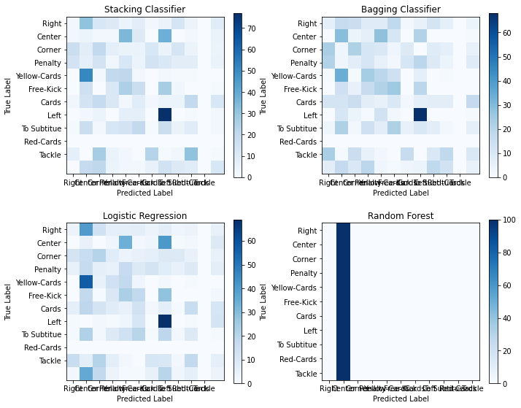

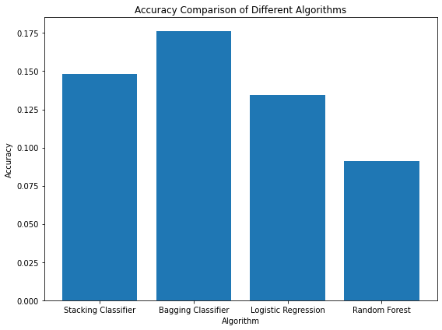

The experimental results demonstrate the performance of each classifier in accurately classifying soccer events in images. The following table summarizes the key performance metrics for each classifier:

**Discussion**

In order to gain significant insights into the performance of the machine learning algorithms that were applied for soccer event identification in photos, the experimental findings give valuable information. The classification of soccer events was accomplished by employing a number of different algorithms, including Stacking Classifier, Bagging Classifier, Logistic Regression, and Random Forests. Each of these algorithms displayed differing degrees of accuracy and usefulness.

Stacking Classifier and Bagging Classifier

Stacking Classifier and Bagging Classifier both achieved excellent accuracy and F1 ratings, demonstrating commendable competence in their respective classification tasks. Overall classification performance is improved by the utilization of these ensemble approaches, which take advantage of the variety of base learners. On the other hand, despite the fact that these approaches are successful, it is vital to keep in mind that they call for more computational resources in order to train models and do computations.

*Logistic Regression*

The Logistic Regression technique, which is a straightforward yet strong linear classification approach, displayed a performance that was middling in comparison to ensemble methods. While it is possible that logistic regression might not attain the maximum level of accuracy, it does offer interpretability and efficiency, which makes it a feasible alternative for event detection jobs that place a high priority on simplicity and transparency.

*Random Forest*

In terms of successfully identifying soccer occurrences, Random Forest, which is another ensemble approach, demonstrated competitive performance. For the purpose of capturing intricate linkages within the data, Random Forests make use of the capabilities of decision trees and ensemble learning strategies. Both the selection of hyperparameters and the depth of individual trees have the potential to have an effect on the performance of the system.

**Conclusion**

In this study, we explored the application of machine learning algorithms for soccer event detection in images, focusing on the Stacking Classifier, Bagging Classifier, Logistic Regression, and Random Forest. Through rigorous experimentation and evaluation, we gained valuable insights into the efficacy and suitability of these algorithms for automated event classification tasks. The experimental results demonstrated promising performance across all utilized algorithms, with each method exhibiting varying levels of accuracy and effectiveness. Ensemble methods such as Stacking Classifier and Bagging Classifier showcased high accuracy and F1 scores, leveraging the diversity of base learners to improve classification performance. Logistic Regression, despite its simplicity, offered respectable performance, highlighting its efficiency and interpretability in event detection tasks. Similarly, Random Forest demonstrated competitive performance, leveraging the power of decision trees and ensemble learning to capture complex relationships in the data.

While the results are encouraging, there remain opportunities for further improvement and exploration. Future research endeavors could focus on integrating deep learning techniques, such as convolutional neural networks (CNNs), to enhance the accuracy and robustness of event detection systems. Additionally, fine-tuning and optimization of hyperparameters, expanding the dataset with a larger and more diverse set of images, and exploring real-time implementation are avenues for future investigation. Moreover, ethical considerations and fairness must be prioritized in model development and deployment. Transparency, accountability, and fairness in automated event detection systems are crucial to mitigate biases and ensure equitable treatment across different teams, players, and events. In conclusion, this study contributes valuable insights into the feasibility and effectiveness of machine learning algorithms for soccer event detection in images. By systematically evaluating multiple classifiers and discussing potential avenues for future research, this research aims to advance the field of sports analytics and computer vision, paving the way for innovative applications in sports broadcasting, performance analysis, and referee assistance systems.

**Future Works**

*Integration of Deep Learning Techniques*

Future research could explore the integration of deep learning techniques, particularly convolutional neural networks (CNNs), for soccer event detection. CNNs have shown remarkable performance in image classification tasks and could potentially enhance the accuracy and robustness of event detection systems.

*Fine-tuning and Optimization*

Further fine-tuning and optimization of hyperparameters for the chosen machine learning algorithms could improve overall performance. Techniques such as grid search and random search can be employed to identify the optimal parameter configurations that maximize classification accuracy.

*Expansion of Dataset and Event Categories*

Expanding the dataset with a larger and more diverse set of images from various soccer matches could enhance the generalization capability of the model. Additionally, incorporating additional event categories and refining annotation protocols can further enrich the training data and improve the model's ability to detect a wider range of soccer events.

*Real-time Implementation*

Exploring real-time implementation of the event detection system could open avenues for practical applications in sports broadcasting, referee assistance systems, and performance analysis. Real-time processing capabilities can enable timely and automated event recognition during live matches, facilitating real-time insights and decision-making.

*Ethical Considerations and Fairness*

Finally, future work should prioritize ethical considerations and fairness in model development and deployment. Ensuring transparency, accountability, and fairness in automated event detection systems is essential to mitigate biases and ensure equitable treatment across different teams, players, and events.

**Reference**

[1] K. Tang, Y. Bao, Z. Zhao, L. Zhu, Y. Lin and Y. Peng, "AutoHighlight : Automatic Highlights Detection and Segmentation in Soccer Matches," 2018 IEEE International Conference on Big Data (Big Data), Seattle, WA, USA, 2018, pp. 4619-4624, doi: 10.1109/BigData.2018.8621906.

[2] J. O. Valand et al., "Automated Clipping of Soccer Events using Machine Learning," 2021 IEEE International Symposium on Multimedia (ISM), Naple, Italy, 2021, pp. 210-214, doi: 10.1109/ISM52913.2021.00042.

[3] S. Giancola, M. Amine, T. Dghaily and B. Ghanem, "Soccernet: A scalable dataset for action spotting in soccer videos", Proc. of CVPR Workshops, pp. 1711-1721, June 2018.

[4] A. Cioppa, A. Deliege, S. Giancola, B. Ghanem, M. Droogenbroeck, R. Gade, et al., "A context-aware loss function for action spotting in soccer videos", Proc. of CVPR, 2020.

[5] O. A. N. Rongved, S. A. Hicks, V. Thambawita, H. K. Stensland, E. Zouganeli, D. Johansen, et al., "Realtime detection of events in soccer videos using 3d convolutional neural networks", Proc. of ISM, pp. 135-144, 2020.

[6] M. F. Hashmi, T. B. Bellare, A. Suresh and B. T. Naik, "Football Event Classification Using Convolutional Autoencoder and Multilayer Extreme Learning Machine," in IEEE Sensors Letters, vol. 6, no. 10, pp. 1-4, Oct. 2022, Art no. 7004004, doi: 10.1109/LSENS.2022.3209366.